INSTITUTIONAL DEVELOPMENT PROSPECTUS
VOLUME 0
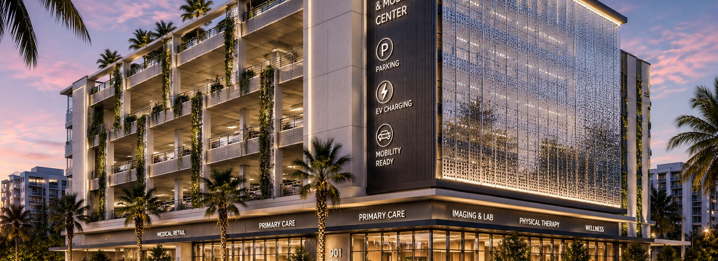
South Andrews
Clinical & Mobility Center
A Healthcare-Anchored Mixed-Use Development
Fort Lauderdale, Florida
0.88 ac  Corner assemblage, 100% usable | < ½ mi  To Broward Health Medical Center | QOZ  Federal Qualified Opportunity Zone

Confidential — Prepared for prospective healthcare, capital, and civic partners
This prospectus accompanies, and is governed by, the project’s Owner’s Development Program (Vol. 1).

VISION
A new healthcare gateway for Fort Lauderdale.
The South Andrews Clinical & Mobility Center is a healthcare-anchored mixed-use development designed to expand patient access, support independent medical providers, strengthen the Broward Health ecosystem, and provide adaptable infrastructure capable of evolving with future transportation and healthcare technologies.

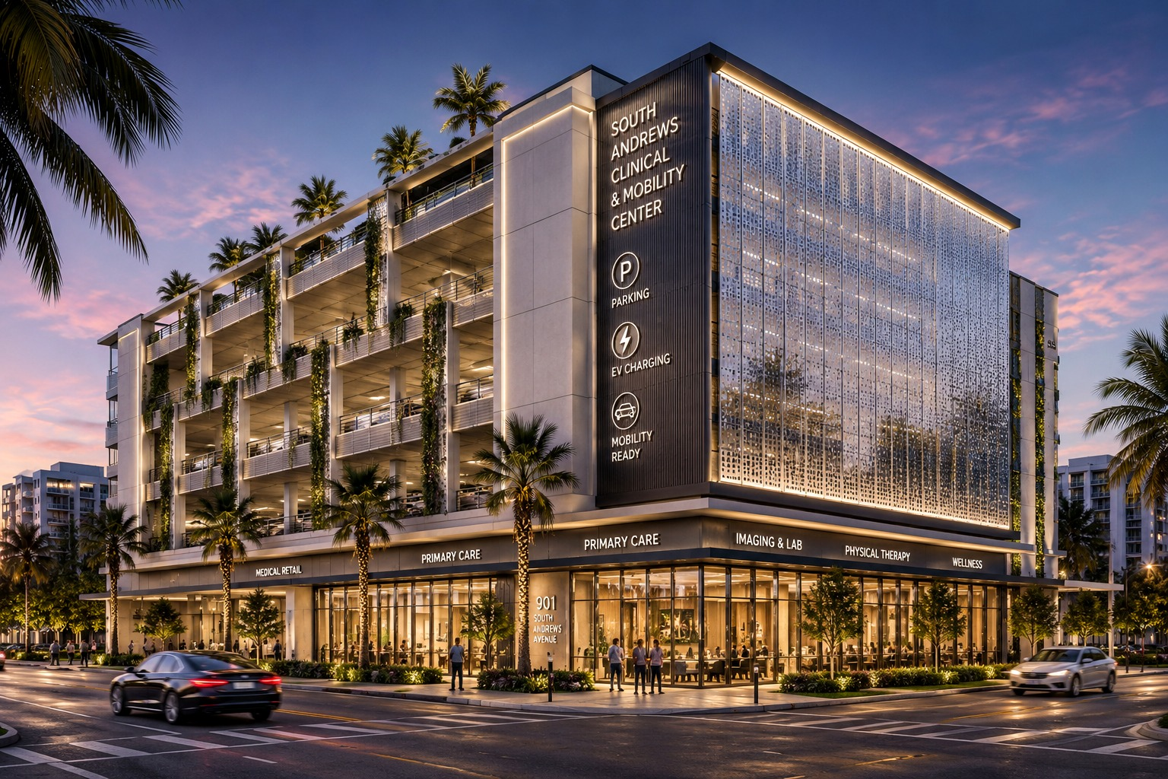
SOUTH ANDREWS CLINICAL & MOBILITY CENTER Illustrative rendering. Design subject to schematic development and entitlement.

THE PROJECT, DEFINED
The South Andrews Clinical & Mobility Center is a healthcare-anchored mixed-use development designed to expand patient access, support independent medical providers, strengthen the Broward Health ecosystem, and provide adaptable infrastructure capable of evolving with future transportation and healthcare technologies.

Official positioning statement · South Andrews Clinical & Mobility Center

A Letter to Prospective Partners

To the reader,
Fort Lauderdale’s South Andrews corridor is in the middle of a healthcare expansion that will define the district for a generation. Less than half a mile from our site, Broward Health is investing in a new medical office building, a graduate medical education program, and the largest resident class in its history. That investment will draw thousands of physicians, staff, and patients into a corridor that is already short on the two things they need most: modern, flexible clinical space and convenient parking.
We assembled this corner to meet that demand directly. The opportunity here is not speculative. It rests on infrastructure already under construction, demographic shifts already underway, and a federal tax structure already in place. Our role is to deliver an institutional-quality asset that serves patients and providers, performs for investors, and contributes to the City’s long-term vision for the South Regional Activity Center.
We have deliberately built this project on evidence rather than ambition. The pages that follow set out the case as we would present it to our own investment committee: the demand, the economics, the execution plan, and the risks. Where the future is uncertain — in mobility, in technology — we have designed for optionality without asking today’s capital to underwrite tomorrow’s assumptions.
If the case resonates, we would welcome a conversation.

Respectfully,

The Ownership
South Andrews Clinical & Mobility Center

A note on this document. This brief presents vision, strategy, and economics. Engineering detail, full assumptions, and the complete decision record are held in the Owner’s Development Program, available to partners under diligence.

Executive Summary

A healthcare-anchored mixed-use development on a fully usable corner assemblage, half a mile from an expanding Level I trauma hospital, inside a federal Opportunity Zone — designed to capture demand the hospital itself cannot absorb.
The South Andrews Clinical & Mobility Center pairs a structured-parking podium with ground-floor medical retail and flexible clinical and medical co-working space above. The concept is engineered from day one for adaptability, so the asset can evolve as healthcare delivery and transportation change over the coming decades.
The thesis in brief
- A real, local demand engine. Broward Health’s expansion is displacing independent practices and intensifying an already strained parking supply. We capture that spillover.
- Differentiated, not duplicative. Rather than compete with the hospital’s new shell space, we offer turnkey medical co-working, a deliberate parking surplus, and convertible structure that competitors cannot easily match.
- Tax-advantaged long-term hold. The site’s Qualified Opportunity Zone status materially strengthens after-tax returns for a patient, institutional hold.
- Optionality without speculation. Power, conduit, and structure are positioned for future EV and mobility uses; none of it is underwritten as day-one revenue.

What we are asking the reader to evaluate
Whether the demand case — hospital-driven, demographic, and structural — justifies a closer look; and whether the combination of healthcare anchoring, parking economics, and Opportunity Zone treatment fits your mandate. The remainder of this brief makes that case.

Why This Cannot Wait

Several independent trends are aligning in the same corridor at the same time. None depends on the others; together they define a development window.
This is an observation about timing, not a sales argument. Each of the conditions below is documented in the project research and is verifiable today. What makes the moment notable is their simultaneity.
✓ Broward Health expansion already underway — a funded 188,000 SF MOB, a new GME hub, and the system’s largest resident class are channeling demand into the corridor now
✓ Opportunity Zone incentives currently available — federal QOZ treatment rewards capital committed to a long-term hold in this census tract
✓ Physician shortages creating sustained demand — a projected statewide shortage exceeding 18,000 FTEs sustains long-run demand for clinical space
✓ Transit investment advancing — the site sits between an existing Brightline station and a planned commuter-rail station to the south
✓ Limited remaining development sites in the corridor — fully usable, well-located parcels adjacent to the hospital are scarce
✓ Healthcare capital remains active — premium healthcare assets in the region continue to attract liquid, competitive capital
✓ Parking shortages already affecting operations — the corridor’s parking deficit is present today and will intensify with new delivery and rail demand

“The convergence of these independent trends creates a rare development window that may not exist in the same form in future years.”

01 The Opportunity
A demand gap created by infrastructure already under construction

The corridor is absorbing a historic healthcare expansion while the supply of flexible clinical space and parking has not kept pace. That gap is the opportunity.
Three forces are converging on the same few blocks of South Andrews Avenue at the same time. A major hospital system is expanding and consolidating. A statewide physician shortage is pushing independent practitioners toward flexible, lower-overhead space. And a federal tax incentive is rewarding patient capital that commits to the corridor now. Each force is independently verifiable. Together, they define a window.
188,000  SF new hospital MOB underway nearby (SF) | 365  Medical residents — largest class in system history | 18,000+  Projected statewide physician shortage (FTEs)

Why the gap persists
Hospitals build to their own institutional footprint. As Broward Health concentrates high-acuity and academic functions on its main campus, it will displace step-down care, rehabilitation, durable medical equipment vendors, and independent specialists who cannot be accommodated within a restricted hospital envelope. Those uses need a home nearby. The corridor does not currently offer enough modern, flexible space — or enough parking — to house them.
The opportunity, stated plainly
Capture the clinical, retail, and parking demand that the hospital generates but cannot itself absorb — on the closest fully developable corner, with a structure built to adapt as that demand evolves.

The Project in One Diagram
The development thesis, read top to bottom: a funded hospital expansion creates demand that the project is purpose-built to capture and convert into a durable institutional asset.
Broward Health Expansion
Funded MOB · GME hub · largest resident class
↓
Growing Patient Volume
↓
Independent Physicians
Displaced by hospital consolidation
↓
Need flexible clinical space |  | Need convenient parking
↓
South Andrews Clinical & Mobility Center
The purpose-built response
↓
◉  Patients | ✚  Physicians | ▢  Medical Retail | P  Parking
↓
Long-Term Institutional Asset
Figure 1 The development thesis at a glance. Each link is documented in the project research; see the corresponding sections of this prospectus.

02 Why This Site
Location, developability, and entitlement aligned

A 100%-usable corner assemblage, adjacent to the hospital district, between two rail nodes, with flexible zoning and Opportunity Zone treatment — a rare combination on a single parcel.
Attribute | Why it matters
Adjacency | Less than half a mile from Broward Health Medical Center — inside the demand catchment, not adjacent to it
Developability | ± 0.88 acre, 100% usable, efficient corner geometry suited to a parking podium with active frontage
Zoning | RAC-RPO permits intensive urban development with a zero-foot build-to line for an activated streetscape
Height potential | 110 ft (~10 stories) by right, with a path to 150 ft through established bonus mechanisms
Transit position | Sited between the Brightline station to the north and a future commuter-rail station to the south
Opportunity Zone | Federal QOZ designation enabling capital-gains deferral and reduction on a long-term hold
Visibility | Corner prominence with protected northern views across Hardy Park

Verified vs. forward-looking
The site attributes above are drawn from survey, appraisal, and zoning research and are treated as established. Final entitlement terms — the achievable height path and parking method — will be confirmed with the City during pre-application, as set out in the Owner’s Development Program.

03 The Broward Health Transformation
An anchor of demand, already funded and under construction

The demand case rests on capital already committed by one of the region’s largest health systems — not on a forecast of future investment.
Half a mile south of the site, Broward Health is executing a master-plan expansion that anchors the entire thesis. The components below are funded and progressing, and each one channels physicians, staff, patients, and visitors into the corridor.
Component | Significance to the corridor
New medical office building | An eight-story, 188,000 SF MOB adjacent to the main campus, opening 2027, housing cardiovascular, primary care, neuroscience, women’s health and more — with exam rooms expandable over time
Graduate medical education | A new GME hub training 365 residents and fellows — the largest class in the system’s history — seeding the corridor with medical professionals
Consolidation effect | As the hospital concentrates high-acuity and academic functions, it displaces independent and step-down practices that need nearby space
Parking pressure | The hospital’s own new parking is largely absorbed by its new MOB and resident influx — it does not resolve the corridor’s deficit

Why this de-risks the project
Our demand does not depend on attracting a hospital to the area — the hospital is already here and already expanding. We are positioned to absorb the overflow that a consolidating institution predictably generates.

04 The Parking Opportunity
Enabling infrastructure with its own cash flow

Parking is not an amenity in this district — it is scarce, revenue-generating infrastructure that also unlocks the clinical floors above it.
Medical uses carry parking demands well above standard office — institutional standards call for four to five spaces per thousand square feet of clinical area. In a corridor where supply is already strained and a future commuter-rail station will add daily demand, structured parking becomes a durable, cash-flowing use in its own right.
Three revenue layers from one structure
- Clinical parking by day. Serving the building’s own patients and providers at the elevated ratios medical use requires.
- Public and commuter parking off-peak. Monetizing the same spaces in evenings and on weekends, and capturing future rail-station overflow.
- Future mobility uses. Pre-positioned for expanded EV charging and, should demand emerge, mobility-fleet services — without committing capital today.

Built to convert
The podium is designed with flat floor plates, removable ramps, and generous floor-to-floor heights so that, if vehicle demand falls as mobility evolves, parking levels can be converted to clinical, office, or other occupied use. The asset is built to remain valuable across multiple futures.

05 Healthcare Market Drivers
Structural demand, not a cycle

South Florida’s medical real estate demand is driven by demographics and a structural shift to outpatient care — forces that persist across economic cycles.
Driver | What it means for this asset
Aging demographics | A growing, aging population sustains long-run demand for outpatient and specialty care
Shift to outpatient | Care continues migrating from hospital campuses to off-campus, specialized facilities near where patients live
Rise of medical co-working | Independent physicians increasingly prefer turnkey, flexible suites over long single-tenant leases — the segment we anchor
Affluent catchment | A high-income residential base in the surrounding ZIP code supports wellness, medspa, and premium services
Telehealth-resilient design | Smaller, flexible consultation suites hedge against shifts in physical-footprint needs

A disciplined read of the market
We acknowledge near-term softening: new medical-office supply has lifted vacancy in the county. Our response is to differentiate — turnkey co-working and a parking surplus that aging, generic competitors cannot offer — rather than add another undifferentiated shell to the pipeline.

06 Development Vision
An institutional asset designed to endure

A civic-quality building that serves patients and providers today and adapts to whatever healthcare and mobility become tomorrow.

Figure 2 Ground-floor medical retail activates the South Andrews frontage beneath a green-screened, convertible parking podium and a luminous, future-ready facade. Illustrative rendering.
The vision is deliberately durable rather than novel. The most sustainable building is one that remains useful for generations, so the design prioritizes flexibility, resilience, and quality that ages well over optimization for a single moment in the market.
Design commitments
- Healthcare first. Every major decision improves patient access, provider efficiency, or healthcare economics.
- Flexibility as value. Adaptable floor plates and a universal structural grid let the building re-tenant and convert over time.
- Resilience by design. The entire site sits in a flood zone; critical systems are elevated and stormwater is managed to the City’s resilient standard.
- An activated street. Ground-floor medical retail at the build-to line strengthens the public realm and the City’s vision for the district.
- Optionality, not speculation. Future EV, mobility, and digital uses are enabled in the structure but never required for the project to perform.

Proposed Development Program

A vertically integrated program: parking podium, ground-floor medical retail, and flexible clinical and co-working space above — sized during design, not before.
Component areas are intentionally not fixed at this stage. They will be set during schematic design, informed by a parking and program test-fit and the financial model. The table below describes each component’s role; precise square footages follow design, not precede it.
Component | Role | Area
Ground floor | Medical retail, lobby, drop-off, loading; critical systems elevated | To be determined during Schematic Design
Parking podium | Convertible structured parking; shared day/off-peak use | To be determined during Schematic Design
Medical office | Flexible outpatient suites, decoupled from inpatient code | To be determined during Schematic Design
Medical co-working | Turnkey, fully serviced suites under a single operator | To be determined during Schematic Design
Medical retail | Pharmacy, urgent care, DME, wellness, food & beverage | To be determined during Schematic Design
Amenity | Tenant amenity and rooftop terrace | To be determined during Schematic Design
Future EV / mobility | Conduit and capacity in place; activated on demand | Optionality (not day-one)

Phasing logic
Phase 1 delivers the parking podium and ground-floor retail — the cash-flowing, demand-proven base. Phase 2 stacks the clinical and co-working floors on a structural grid established in Phase 1. Phase 3 preserves mobility and conversion optionality, activated only on demonstrated demand.

07 Economic Impact
Value to the corridor and the City

Beyond its returns to capital, the project strengthens the corridor’s tax base, supports healthcare employment, and advances the City’s plan for the South Regional Activity Center.
Where the value accrues
- Healthcare employment and access. Flexible clinical space keeps independent practitioners and step-down care in the corridor, sustaining medical jobs and patient access near the hospital.
- Tax base and reinvestment. An institutional-quality asset on a currently underutilized corner adds durable value to the SRAC tax base, with Opportunity Zone treatment encouraging long-term reinvestment.
- Streetscape and activation. Ground-floor retail and a public-realm presence contribute to the walkable, active downtown-adjacent district the City has prioritized.
- Mobility alignment. Parking and mobility infrastructure align with regional first-mile / last-mile and transit-hub objectives, supporting public-private collaboration.

A note on figures
Specific job, tax-revenue, and investment figures will be quantified in the economic-impact analysis that accompanies entitlement. We have chosen not to estimate them here rather than present numbers we have not yet substantiated.

Public Benefits

The project is designed to be a civic asset — improving healthcare access, public space, and resilience in equal measure to its private returns.
Public benefit | How the project delivers it
Improved healthcare access | Convenient outpatient care, urgent care as a triage buffer, and pharmacy/DME serving post-discharge patients
Parking relief | A structured-parking surplus easing a corridor-wide deficit and absorbing future rail-station demand
Active, safe streetscape | Ground-floor retail and pedestrian-first frontage at the build-to line
Climate resilience | Flood-resilient design and stormwater management consistent with the City’s resilient master plan
Transit-supportive development | A mobility-ready building positioned between two rail nodes
Long-term stewardship | A durable, adaptable asset intended for a multi-decade hold rather than a quick exit

Development Timeline

The project has completed its research and governing-document phases and is entering due diligence and design.
Stage | Status | Focus
■ Research | Complete | Market, site, feasibility, benchmarks
■ Owner’s Development Program | Complete | Governing manual (Vol. 1)
◆ Due Diligence | Underway | Zoning, utilities, traffic, geotech, environmental
◆ Entitlements | Initiating | City pre-application and review
□ Schematic Design | Next | Test-fit-driven program
□ Design Development | Future | Detailed design
□ Construction Documents | Future | Permitting set
□ Financing | Future | QOZ equity + construction debt
□ Construction | Future | Phase 1: parking + retail
□ Stabilization | Future | Clinical / co-working lease-up
□ Future Expansion | Future | Mobility / conversion optionality

■ Complete ◆ Underway □ Future

08 Investment Highlights
Why this fits an institutional mandate

Highlight | Rationale
Inelastic demand anchor | Hospital-driven healthcare demand is structural and local, not cyclical
Revenue diversification | Parking, medical retail, clinical, and co-working income hedge single-use vacancy
Tax-advantaged structure | Opportunity Zone treatment enhances after-tax returns on a long-term hold
Durable, convertible asset | Flexible structure positions the asset to re-tenant and convert as the market evolves
Differentiated product | Co-working and parking surplus that incumbents cannot readily replicate
Public-sector alignment | Mobility and streetscape goals open avenues for public-private collaboration
Patient capital fit | A multi-decade hold suited to institutions, family offices, and infrastructure-minded investors

Return-related disclosure
This brief intentionally does not state target returns. A full underwriting — with scenario and sensitivity analysis on cost, rate, and absorption — is provided to partners under diligence. We would rather earn the meeting on the strength of the demand case than on unsubstantiated projections.

Risk Management Philosophy

We name risks early, mitigate them by design, and validate them with specialists before committing capital.
Institutional partners are right to ask what could go wrong. Our approach is to surface the principal risks candidly and to show that each has a concrete mitigation path. The most material risks and how we manage them:
Risk | Our approach | Validation
Flood / storm exposure | Elevate critical systems; manage stormwater to the City’s resilient standard | Civil and hydrology design
Power capacity | Confirm electrical capacity early; design redundancy for clinical continuity | Utility load study
Market softening | Differentiate via co-working and parking surplus; avoid generic shell space | Updated absorption at lease-up
Cost and rate environment | Value-engineer the adaptability premium; stress-test the model | Contractor pricing; sensitivity
Construction logistics | Just-in-time delivery and rigorous inspection on a tight site | CM logistics plan
Technology uncertainty | Preserve optionality; never underwrite speculative mobility revenue | Demand-gated activation

Evidence before assumption
Our governing principle is that verified facts outrank assumptions, and that uncertainty is named rather than hidden. The full risk register, with probability and impact ratings, sits in the Owner’s Development Program.

09 Why This Project Wins
The case in one view

The project wins because every element of the thesis is grounded in something already real — and because the design keeps options open as the market changes.
The five reasons, distilled
- The demand is already here. A funded hospital expansion, not a forecast, drives the need for clinical space and parking.
- The site is uniquely suited. A fully usable corner, adjacent to the hospital, between two rail nodes, in an Opportunity Zone.
- The product is differentiated. Co-working, parking surplus, and convertibility set the asset apart from generic medical office.
- The economics are tax-advantaged and diversified. Opportunity Zone treatment plus multiple revenue layers support a durable, long-term hold.
- The execution is disciplined. A governing manual, a clear phasing plan, and an evidence-first risk posture de-risk delivery.

The single sentence
An institutional-quality, healthcare-anchored asset that captures demand a nearby hospital is already creating — built to perform today and to adapt for decades.

Next Steps

We are seeking the right healthcare, capital, and civic partners for the next phase. The immediate path is clear.
# | Action | Partner relevance
1 | Introductory meeting and mutual fit assessment | All partners
2 | Access to the Owner’s Development Program under diligence | Investors, lenders, health systems
3 | Healthcare partnership and co-working discussions | Health systems, operators, brokers
4 | Review of the financial model and underwriting | Investors, private equity, lenders
5 | City coordination and entitlement alignment | City and economic-development partners

To begin a conversation
This brief is intended as the basis for a first meeting. Partners who wish to proceed will be given access to the full Owner’s Development Program, the financial model, and the diligence materials under appropriate confidentiality.

Appendix · Project Snapshot

A reference summary of verified project facts. Items not yet determined are labeled accordingly.
Attribute | Value
Property | 901–915 South Andrews Avenue, Fort Lauderdale, FL 33316
Parcel size | ± 0.88 acre (± 38,207 SF), 100% usable
Zoning | RAC-RPO (Regional Activity Center – Residential & Professional Office)
Future land use | South Regional Activity Center (SRAC)
Opportunity Zone | Yes — federal Qualified Opportunity Zone
Flood zone | FEMA Zone AE (entire site)
Primary frontage | South Andrews Avenue, ± 275 ft (zero-foot build-to line)
Height potential | 110 ft by right; path to 150 ft via bonuses
Healthcare anchor | Broward Health Medical Center, less than ½ mile south
Transit context | Between Brightline (north) and future commuter-rail station (south)
Concept | Convertible parking podium + ground-floor medical retail + flexible clinical / co-working
Development status | Pre-Schematic Design; Owner’s Development Program (Vol. 1) issued
Program areas | To be determined during Schematic Design
Target hold | Long-term (Opportunity Zone aligned, ≥ 10 years)

This Executive Brief (Vol. 0) is a summary prepared for prospective partners. It is governed by, and should be read alongside, the Owner’s Development Program (Vol. 1). Verified facts are distinguished from items requiring validation throughout. Nothing herein constitutes an offer to sell securities or a commitment to invest.

